Quarter 3 Goals
Standards 6.EE.1,2a,2b,2c,3,4,6,6.EE.5,7,8,6.EE.9, 6.G.1,3

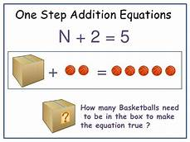

I can use order of operations to solve a one step equation with one variable.

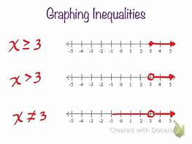
I can graph an inequality on a numberline.

